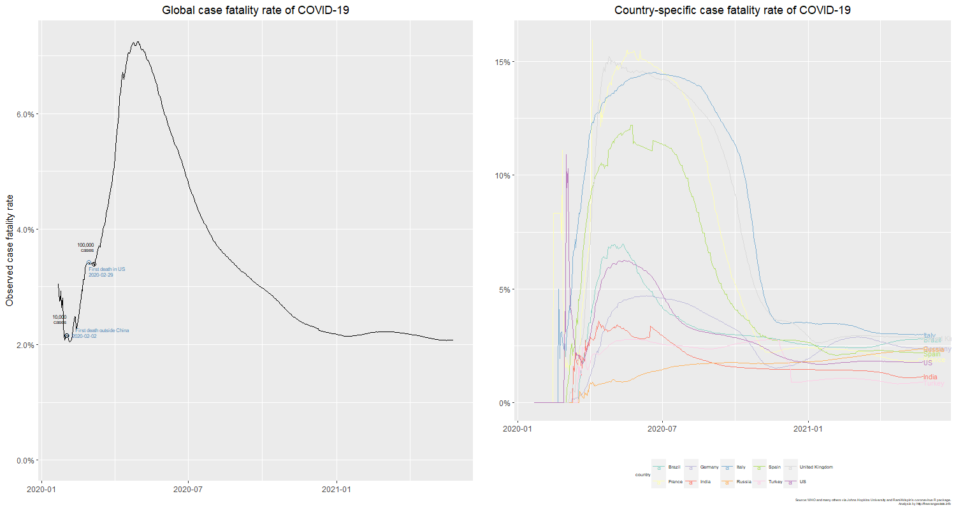

* *Global case fatality rate of COVID-19*
  + *Showcases the line graph of the fatality rate globally*
  + *The black points show* 
    - *10,000 global confirmed cases*
    - *100,000 global confirmed cases*
  + The blue points show
    - When the first fatality occurred outside of China and the respective date
      * The date is significant as China is the origin country, therefore looking at the first spread and according death is significant
    - When the first fatality occurred in the United States
      * The fatality is significant in terms of assessing the United States COVID-19 cases
  + The peak of fatality was in April 2020
  + The fatality rate was increasing at a rapid pace until April 2020 and started to rapidly decrease since then
* *Country Specific case fatality rate of COVID-19*
  + The line graph showcases the Top 10 confirmed cases countries and their respective fatality rates
  + The respective countries are in different colors
    - Shown in legend
    - Shown at the endpoints of the graphs
  + Currently, Italy has the highest fatality rate
  + Historically, France had the highest fatality rate reached around the time when global fatality rate was at its highest
  + European countries had extremely high fatality rate in April 2020, when the global fatality rate was at its highest
    - It can be inferred from this that the European countries’ significantly high fatality rate was one of the main causes of global fatality rate increase.